Southampton Christmas Decorations Committee
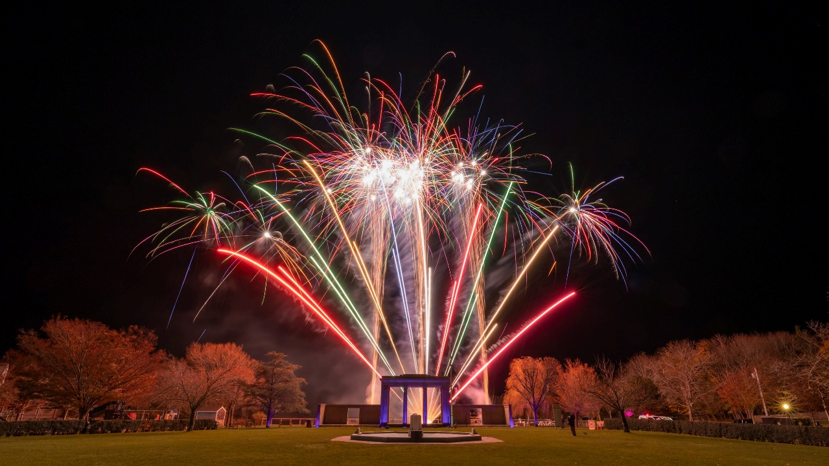
2024 Events , Saturday, November 30th
· 4:30PM at Dusk - Parade Of Lights
Featuring decorated vehicles representing
our volunteer Fire and EMS departments
· 5:30PM - Tree Lighting Ceremony
In Agawam Park with Holiday Songs by
Southampton High School’s
Voices of Southampton (VOSH)
· Fireworks Display
with Exciting New Surprises
· Holiday Window Decorations Contest
Stroll through the Village and enjoy all the
beautiful windows decorated for the Season
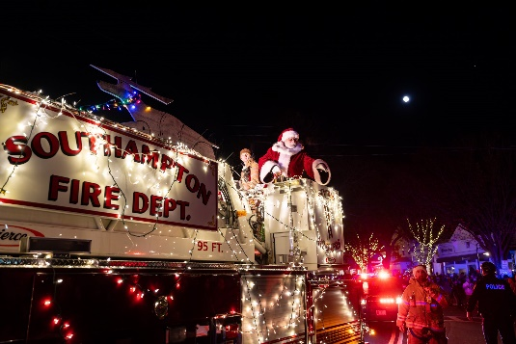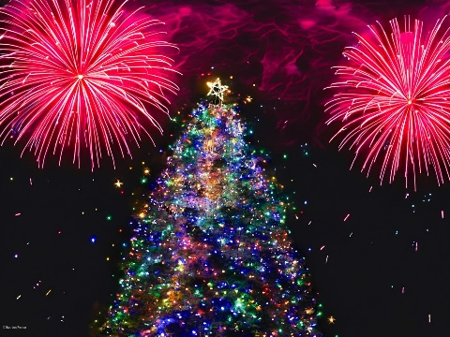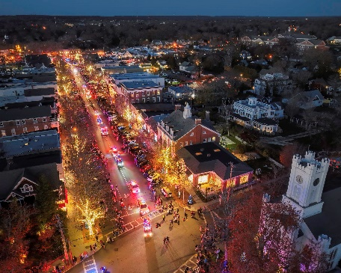
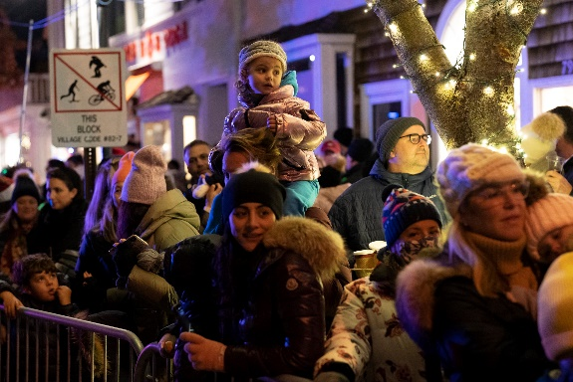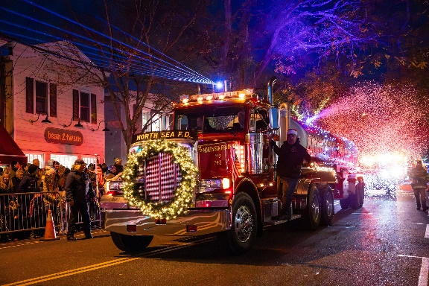
History
The Christmas Decorations Committee began in the mid 1950’s by Jack and Nancy Rist, Artie Palma, Jack Lillywhite and Bob Keane. Each year, on the first Friday in December they held the official Village Christmas Tree Lighting at the Chamber of Commerce.
In 1975 Jack and Nancy Rist passed the torch to Ann & Bill Yawney and a committee of business owners and residents was formed.
Early on, funds would be donated by members of the community who were delighted by the sparkling lit trees and wreaths placed throughout the Village business district. Over the years, the Committee has continued their fundraising efforts through an annual appeal which continues today.
The generous donations have enabled the Christmas Committee to fund underground wiring throughout Main Street and Jobs Lane and purchasing of LED lights to be more environmentally friendly. In addition, the antique angels from Saks Fifth Avenue that adorn the fence along Jobs Lane were all refurbished as well as the nativity scene, the iconic Santa Claus and his reindeer and the nostalgic bell that hangs over Main Street. In 2020 the Committee funded the purchase of a beautiful new spruce tree for Agawam Park.
It has been approximately 25 years since the Parade of Lights began, brought to the holiday event by Millie Fellingham and the Southampton Chamber of Commerce to highlight the Volunteer Fire and EMS Departments.
In 2021 after 46 years serving on The Christmas Decorations Committee, Ann & Bill Yawney retired and once again the torch has been passed.
We will continue the traditions of keeping Southampton Village merry and bright throughout the holiday season!
All Donations Support
· Live Christmas Trees throughout the Business District
· Christmas Lights
· Wreaths
· Maintenance and Display of Antique Angels on Jobs Lane
· Thanksgiving Weekend Holiday Kick-Off
with Parade of Lights, Tree Lighting, Fireworks Display,
and More! https://christmasdecorationscommittee.networkforgood.com
Christmas Decorations Committee
Andrew Pilaro Mark Parash Julie Fitzgerald Grace Meaney
President Vice President Secretary
For More Information or Questions Contact
southamptonchristmas11968@gmail.com
Photos by: Marianne Barnett, Ron Esposito, Mary Godfrey & Brandon Remlar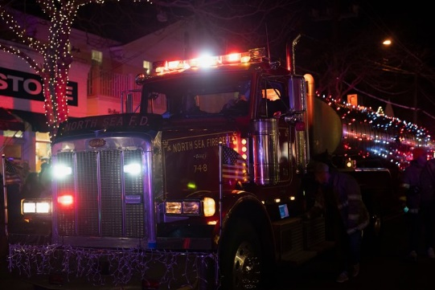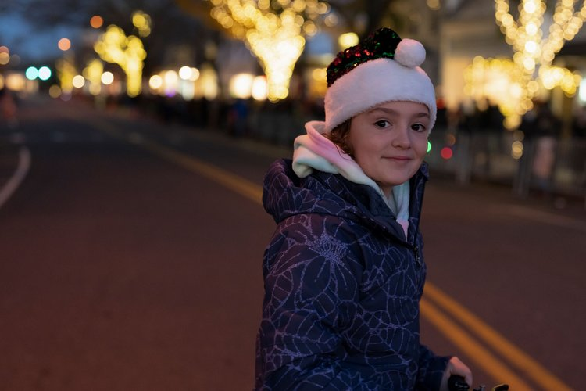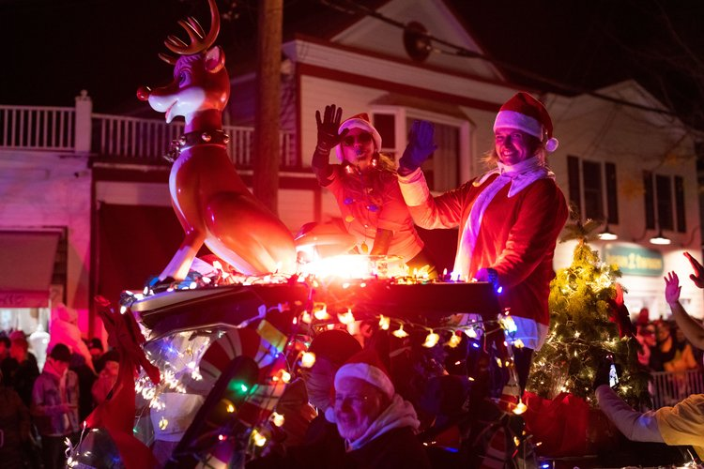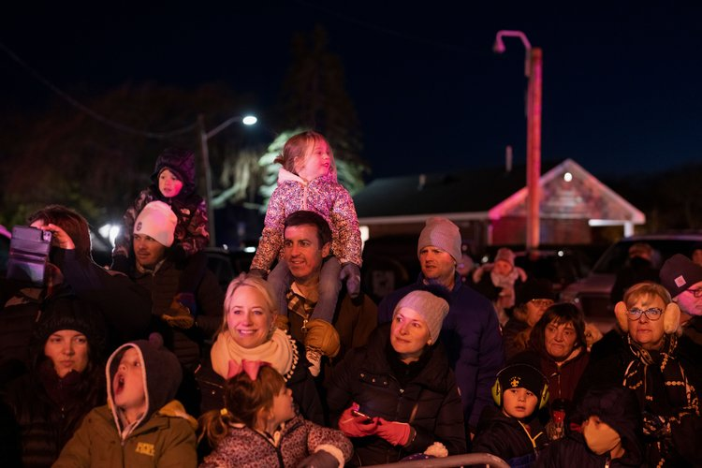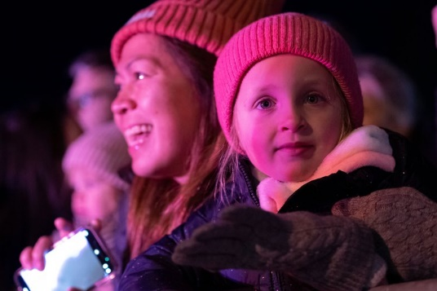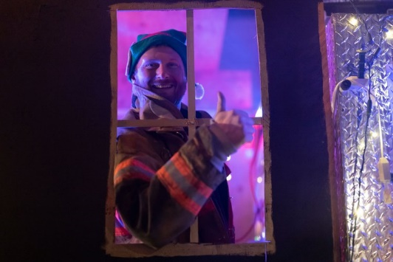
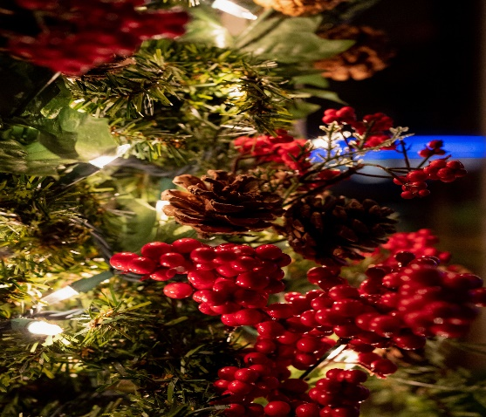
Po Box 3096
Southampton, NY 11969
Site By Dead On Design
https://deadondesign.com

