Just Transition Southampton: Survey and Community Meeting #1
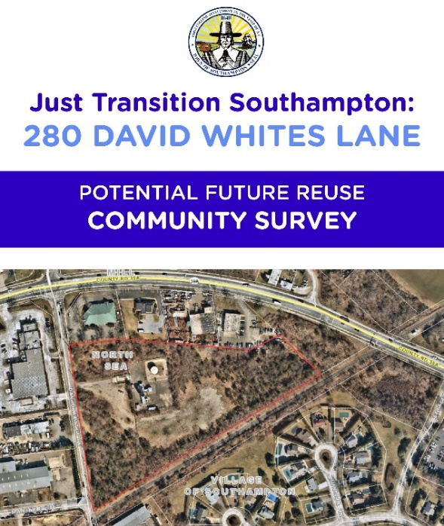
The Town of Southampton is undertaking a site reuse planning study for the electrical generation facility located at 280 David Whites Lane. This study is intended to ideate, imagine, and explore possible future reuses of the site. We invite you to provide your input on the community survey!
Please take a few minutes to complete the survey, your input will help Southampton officials obtain important community feedback to assist them in understanding the community’s vision and make informed decisions about the potential future reuse of the electrical generation site à https://www.surveymonkey.com/r/FDBCXD3
Please join us for the Virtual Public Meeting being hosted by the Town on Wednesday, April 3rd from 6:30 – 8:00 PM EST to learn more and provide additional input on the potential future reuse of the site.
Click here to register for the public meeting à https://us02web.zoom.us/meeting/register/tZ0rcOuvqTMvGNbCA8dwrXBkNEOP7THCdWqj

